NewFeng Charger PROFINET Communication Description

1. Preparations (GSD Installation and Network Configuration)
- Install the corresponding GSDML file of the charger in TIA Portal.
- Ensure the PLC station name is identical to the charger station name.
- Ensure the PLC and charger are on the same network segment. If they are not on the same network segment, modify the IP addresses of PLC, HMI and CAN on the charger side.

2. Network Configuration Requirements
Complete the PROFINET network configuration as shown in the diagram.

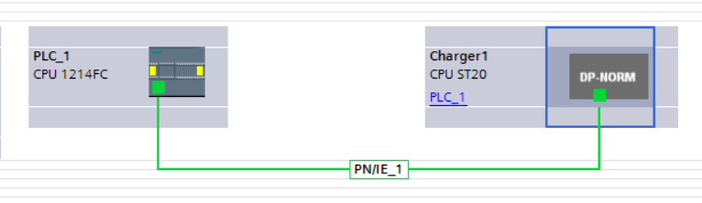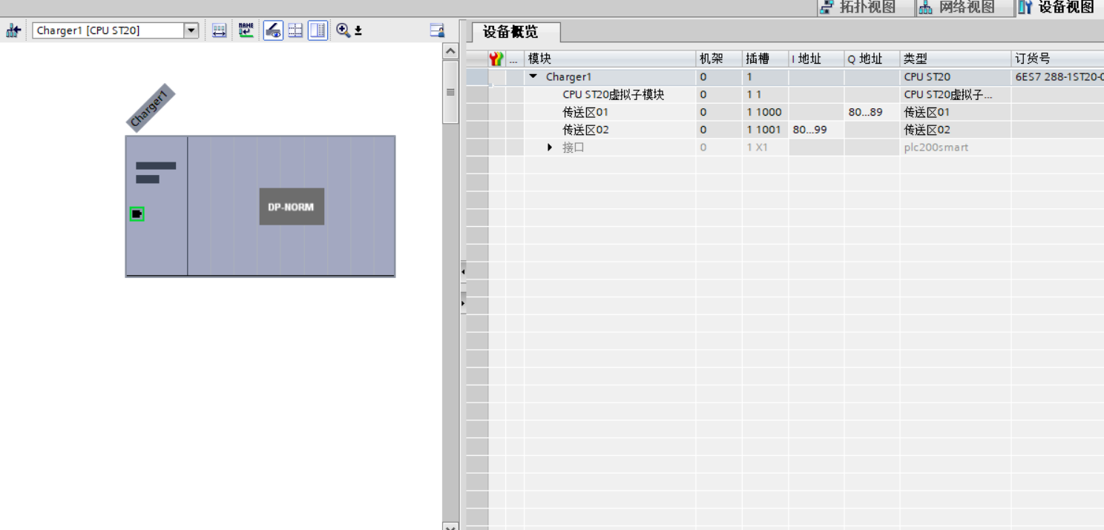

3. Input Area (I Area) Address Definition (Feedback Signals)
Address Format | Data Type | Signal Name | Description
%IDX | REAL | Output Voltage Feedback | Actual Output Voltage
%IDX+4 | REAL | Output Current Feedback | Actual Output Current
%IDX+8 | REAL | Set Voltage Feedback | Set Voltage Value
%IDX+12 | REAL | Set Current Feedback | Set Current Value
%I(X+16).0 | BOOL | Charging Start Feedback | Charging Running Status
%I(X+16).1 | BOOL | Spare | —
%I(X+16).2 | BOOL | Spare | —
%I(X+16).3 | BOOL | Spare | —
%I(X+16).4 | BOOL | Spare | —
%I(X+16).5 | BOOL | Spare | —
%I(X+16).6 | BOOL | Spare | —
%I(X+16).7 | BOOL | Spare | —

4. Output Area (Q Area) Address Definition (Control Signals)
Address Format | Data Type | Signal Name | Description
%QDX | REAL | Set Voltage Output | Issue Target Voltage
%QDX+4 | REAL | Set Current Output | Issue Target Current
%Q(X+8).0 | BOOL | Start Charging | Start Charging Command
%Q(X+8).1 | BOOL | Stop Charging | Stop Charging Command
%Q(X+8).2 | BOOL | Confirm Voltage & Current Setting | Parameter Confirmation Command
%Q(X+8).3 | BOOL | Spare | —
%Q(X+8).4 | BOOL | Spare | —
%Q(X+8).5 | BOOL | Spare | —
%Q(X+8).6 | BOOL | Spare | —
%Q(X+8).7 | BOOL | Spare | —

